**Lab 14**

**To Explain the Working of Registers, Modes of Operation and Implement Universal Register Using IC**

**Note: For all the circuits in the tasks, your logic diagrams should be either hand drawn or from the software logicly. Keep them neat and legible. These circuits will be having many connections so, for simulations, make sure that you label the inputs and outputs clearly. Use Label tag in “logically”. You can also edit the pictures of your outputs in “paint” easily.**

**Tasks**

1. **Construct a logic circuit for 4-bit Shift Register working in PISO mode using D Flip Flop. Simulate your circuit to verify the outputs.**

4-Bit Register in PISO Mode

1. Logic Diagram

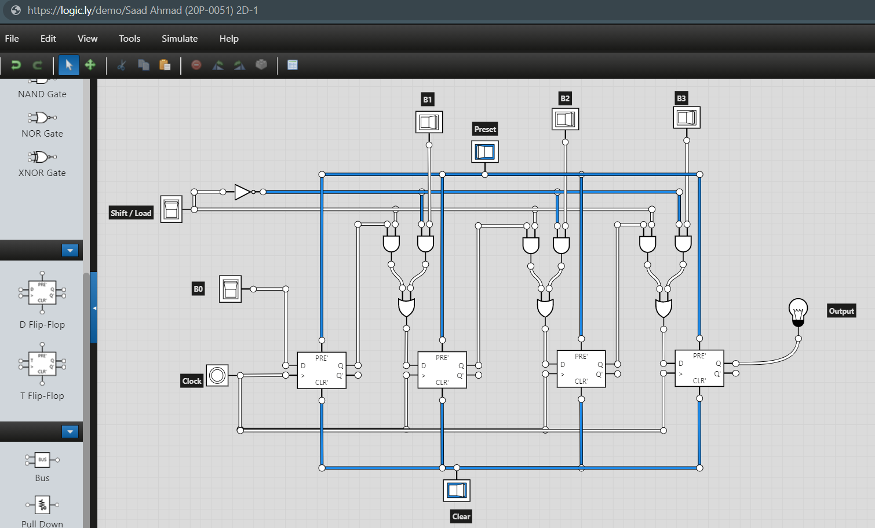

1. Software Simulation

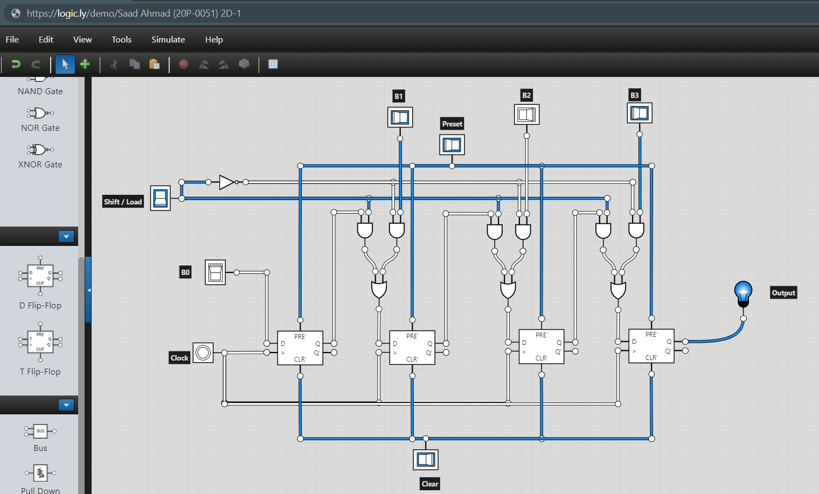

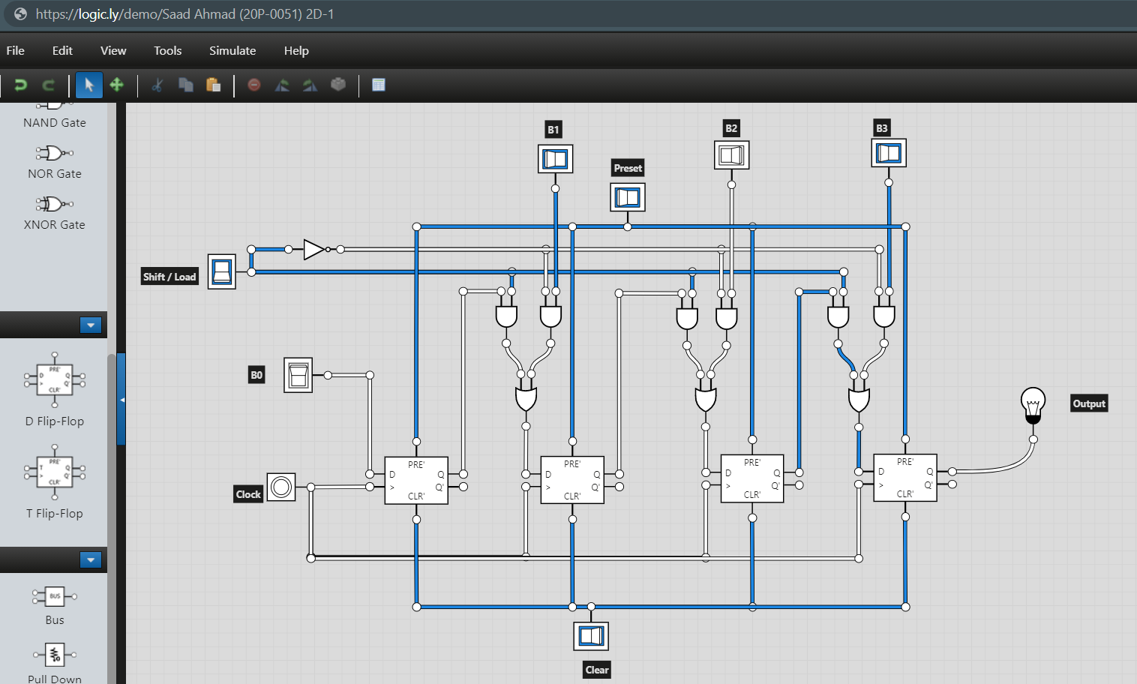

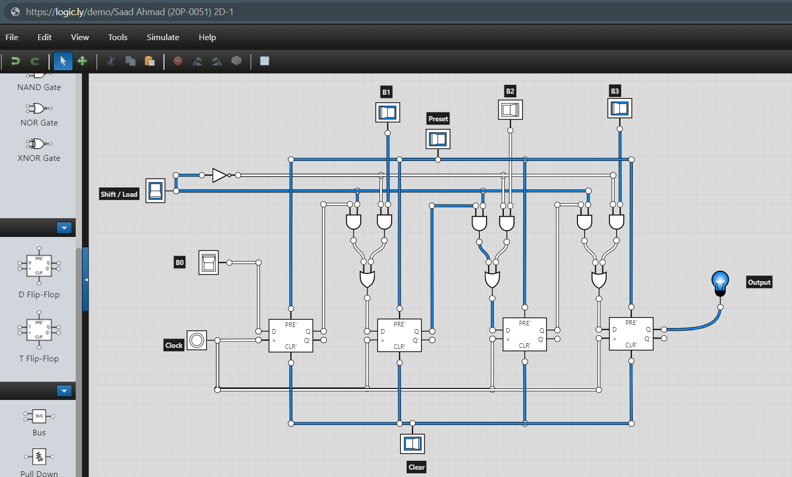

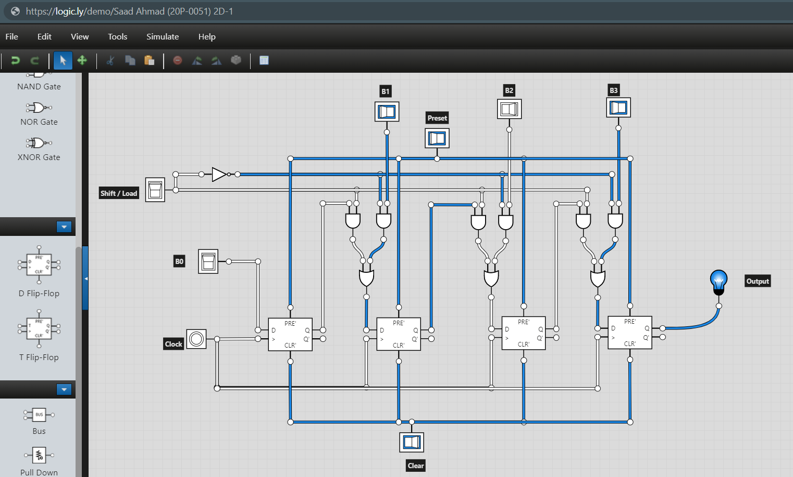

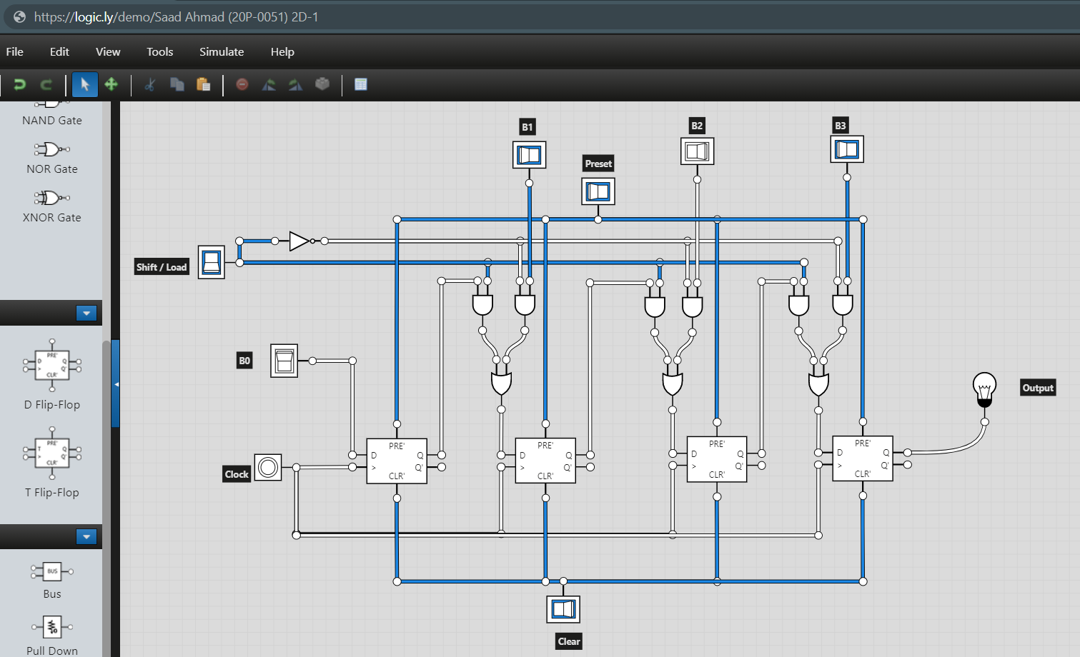

1. **Construct a logic circuit for 4-bit Bidirectional (Left/Right) Shift Register using D Flip Flop. Simulate your circuit to verify the outputs.**
2. Logic Diagram

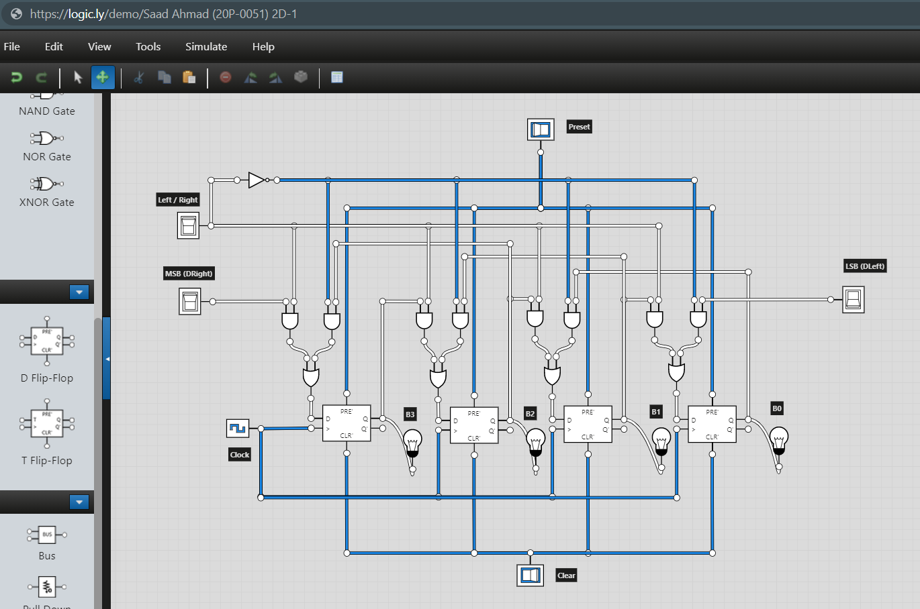

1. Software Simulation

